__________________________________________________________________________________________________

TACT
TM

TA-4700

DIGITAL RADIO SYSTEM SERVICE CHANNEL AND PSTN INTERCONNECT

RACK MOUT VERSION SERIAL/ITEM 755/337

__________________________________________________________________________________________________

USER HANDBOOK

Issue 3, FEBRUARY, 1998, AUTHOR: PETER ZEUG

ACA SUPPLIER’S CODE N468

__________________________________________________________________________________________________

DESIGNED AND MANUFACTURED IN AUSTRALIA

DESIGN TWO THOUSAND PTY LTD

__________________________________________________________________________________________________

DESIGN TWO THOUSAND IS CERTIFIED TO ISO9001

MADE IN AUSTRALIA

__________________________________________________________________________________________________
__________________________________________________________________________________________________

TACT TA-4700

DIGITAL RADIO SYSTEM SERVICE CHANNEL AND PSTN INTERCONNECT (DRSI)

USER HANDBOOK

CONTENTS PAGE

Service Information 1
Introduction 2
Overview 2
Features 2

Block Diagram of Example System 3
Controls 4
Indicators 4
Connectors 4
Installation 5
Telephone Line 5
Local Phone 5
Radio Service Channels 5
Power 5
User Instructions 6
Making an Intercom Site Call 6
Making a PSTN Call 6
DRS Access from the PSTN 6
Master or Site Mode 7
Site Number 7
Call Time Limit & Disconnect Warning Tone 7
Data Call Detect Threshold 7
Programming Summary 8
Specifications in Brief 8

DESIGNED AND MADE IN AUSTRALIA

DESIGN TWO THOUSAND PTY LTD

Telstra Radiocom Design, Network Design and Construction

© Copyright 1998
__________________________________________________________________________________________________

SERVICE INFORMATION

If problems are experienced with the installation or operation of the Digital Radio System Service Channel and PSTN Interconnect please call the Help Desk Number listed below before returning units to the factory for repair.

In most cases, problems can be diagnosed and rectified over the phone, avoiding unnecessary transportation and service costs.

HELP DESK NUMBER:

+61 3 9758 5933 (All hours)

__________________________________________________________________________________________________

TACT TA-4700 DIGITAL RADIO SYTEM SERVICE CHANNEL AND PSTN INTERCONNECT

INTRODUCTION

TACT, the Telephone Access Control Terminal, is a proven hardware platform used for interconnecting conventional and trunked two-way radios to Private Automatic Branch Exchanges (PABXs) and the Public Switched Telephone Network (PSTN).

The TACT architecture (with its radio interfaces, local phone port, PSTN line interface and DTMF encode/decode) is ideally suited for Telstra Digital Radio System (DRS) orderwire (intercom) and PSTN interface facilities, allowing DRS sites to talk to each other and any PSTN telephone.

OVERVIEW

The Digital Radio System Service Channel and PSTN Interconnect (DRSI) provides both PSTN access from any DRS and intercom facilities between DRSs.

Dual Tone Multi Frequency (DTMF) signalling from a standard ‘local’ two wire telephone at each site is used to make ‘internal’ (site) and ‘external’ (PSTN) calls.

The DRSI will replace conventional Orderwire facilities on the DRS relay links that do not provide PSTN access, and Orderwire systems with other limitations.

DESCRIPTION

The DRSI is based on the standard TACT TA-4700 hardware platform. The only custom built hardware is the DRSI specific inbuilt interface card. The DRSI application is primarily a function of custom software.

A DRSI is interfaced to the DRS 4 wire analogue service channel (Tx/Rx audio) via the standard TACT radio interface. A standard two wire analogue telephone is connected to the DRSI ‘local’ phone port. A ‘master’ DRSI in each DRS Orderwire network is also interconnected to a standard two wire ring in/loop out PSTN telephone line for PSTN access.

DRSI audio connections to the service channels are 4 wire, 600R with input and output levels between -30 dBm and +10 dBm.

Interconnection at node radio sites will use the inbuilt 3 way, 4 wire bridge which splits and combines (mixes) audio at factory set flat gain (0 dBm) which is field adjustable by mechanical potentiometers.

Each DRSI is ‘soft’ programmed with its own unique site number so that it may be selectively called.

SYSTEM FACILITIES & FEATURES

- DRS site to site access (Orderwire/Intercom facility).
- PSTN access from DRS sites.
- DRS site access from the PSTN.
- Site call ‘Add-On’ feature.
- Manual PSTN line pick up and hang up during a site call.
- ‘Follow-On’ calls.
- Group call (call and talk to all DRS sites).
- The DRSI provides the operator with voice prompts, guides and responses where required.
- The DRSI provides the operator with Call progress tones.
- Intrusion tone when another party joins and leaves a voice call.

________________________________________________________________________________________________

Contd

- The DRSI is able to detect the presence of a DRS data call. If a data call is in progress, any operator that lifts a handset will hear “data call in progress, try again shortly” which prevents the data from being corrupted. An override code for emergency situations may be provided as a firmware option.
- High bandwidth (>9600 bps data throughput).
- Programmable supervisory timers and network service tone detection for call supervision and call disconnection.
- Programmable voice call disconnect warning sequence with call continue command, as a ‘fall back’ lock up inhibitor.
- DRS access from the PSTN. Any DRS local telephone can be called from any PSTN telephone. Outside callers calling in to the master DRSI will hear “Digital Radio System Interconnect, enter the required site number”.
- Local programming from the inbuilt keypad, and remote programming/diagnostics using DTMF.
- RS232 port for call data/diagnostics.
- Inbuilt 3 way, 4 wire bridge. The third radio service channel interface is strappable for use as a ‘SUPY’ interface which introduces low pass filters (LPFs) (2.2 kHz cross-over frequency) for the application of a nominal 3810 Hz supervisory tone from an externally mounted Supervisory FSK Transceiver. The strapping arrangement switches in LPFs for all telephone send and receive audio and also blocks telephone audio to the Supervisory FSK Transceiver.
- 12 → 48 Volt dc working, polarity and ground insensitive.

BLOCK DIAGRAM OF EXAMPLE SYSTEM

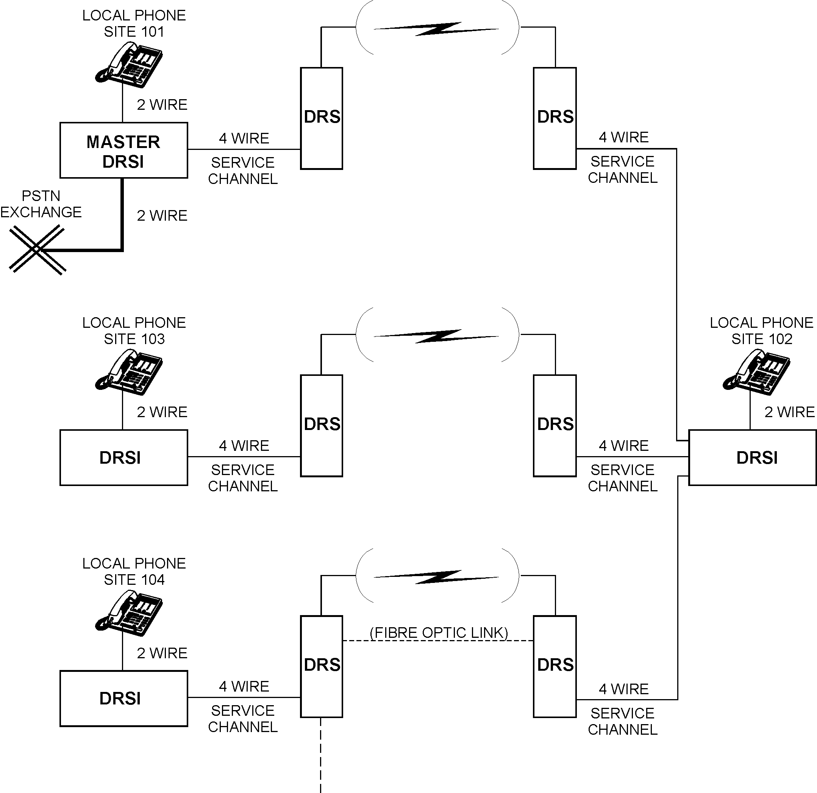
__________________________________________________________________________________________________

DRSI CONTROLS

The DRSI has a twelve button keypad controller used for programming functions. Some programming functions are also possible from any local or remote telephone.

DRSI INDICATORS

Programming progress and success is displayed on the 7 segment monitor display. (Remote operation is prompted and confirmed by the voice synthesizer). The 7 segment monitor display also provides call progress information:

0. = silence
1. = busy tone
2. = dial tone
3. = nu tone
4. = speech
5. = continuous tone
6. = random busy tone
7. = ringing tone
8. (not currently used)
9. = modulated tone

In addition to the monitor display, visual indication of operating progress is provided by six LEDs on the front panel marked ‘POWER’, ‘READY’, ‘CONNECT’, ‘ON AIR’ ‘Tx’, and ‘Rx’.

The ‘POWER’ LED indicates that power is connected and that the internal fuse is intact. The ‘READY’ LED indicates that the system is ready for calls. The ‘CONNECT’ LED illuminates whenever the PSTN telephone line is ‘looped’. The ‘ON AIR’ LED illuminates when a local site telephone is off hook. The Tx LED indicates service channel activity, and the Rx LED indicates that a data call is in progress.

DRSI CONNECTORS

12 → 48V power input: 2.1 mm dc, polarity insensitive. (BL-2 plug, on all new units).
Telephone line: RJ 12
Local Phone: RJ 12 (RJ45 on all new units)
Radio Interface 1: RJ 45
Radio Interface 2: RJ45
Radio Interface 3: RJ45 (Strappable for ‘SUPY’ Interface)
RS232 Port DB9 (Call Data /Diagnostics)
__________________________________________________________________________________________________

INSTALLATION

The DRSI is supplied in a 1 unit high, 19” rack mount enclosure with operating LED’s and keypad controller on the front and radio (RJ45), telephone line (RJ12), local telephone port (RJ45) and power (BL-2) connectors at the back. The DRSI is therefore ideally suited to be mounted in a standard 19” rack with rear access.

Installation is essentially ‘plug and play’ as described here.

CONNECTING THE ‘MASTER’ DRSI TO THE TELEPHONE LINE

The DRSI is connected to the PSTN Line or PABX analogue extension using the RJ 12 to 605 line cord provided. The RJ 12 end is plugged into the socket at the back of the DRSI marked ‘LINE’. The 605 end (other plugs to order) is plugged into a working telephone socket.

When connecting the DRSI to a PABX internal analogue extension, this extension can be programmed to ‘ring’ (direct in termination) when a designated exchange line number is called. This provides full access for callers calling in from any internal extension and/or from any outside line.

CONNECTING THE LOCAL PHONE TO THE DRSI

The local phone (standard two wire analogue) is connected to the DRSI RJ45 socket marked ‘LOCAL PHONE’. The length of wire running to the local phone should not exceed 100 metres of 0.4 mm twisted copper pair. The balance network in the two to four wire hybrid is optimised for a standard Telstra Touchfone 200 or 400.

CONNECTING THE DRSI TO THE RADIO SERVICE CHANNEL(S)

The DRSI may be connected to up three Digital Radio Systems. (The third radio interface may alternatively be strapped to become a ‘SUPY’ interface). The RJ 45 plugs are wired as shown here:

RJ45 plug Pin
1. Not used Pin 1 of RJ45 connector 1
2. Not Used Pin 2 of RJ45 connector 2
3. Rx A Pin 3 of RJ45 connector 3
4. Tx A Pin 4 of RJ45 connector 4
5. Tx B Pin 5 of RJ45 connector 5
6. Rx B Pin 6 of RJ45 connector 6
7. Not used Pin 7 of RJ45 connector 7
8. Not Used Pin 8 of RJ45 connector 8

Note: Tx AB = VF out (to the service channel).
Rx AB = VF in (from the service channel).

CONNECTING POWER TO THE DRSI

The DRSI can be powered from a nominal 12 -> 48V dc supply, +ve or -ve earth, or floating. The power input is polarity insensitive. The nominal operating current is 135 mA @ 48 V with a maximum current of 160 mA when the local phone is ‘off hook’. The power connector supplied is a BL-2 screw/clamp plug.

__________________________________________________________________________________________________

USER INSTRUCTIONS

MAKING AN INTERCOM CALL

- Lift the local phone handset and listen for PSTN/PABX dial tone.
- Press #.
- Dial the required site number and listen for distinctive ring tone “brrrrr ………….brrrrr…”. (single ring bursts).
- If the site does not answer within thirty seconds you are disconnected. If you hang up sooner, ringing stops immediately.
- When the dialled site answers, proceed with the conversation.
- To end the call simply hang up.

Notes:
- Other sites may be called during a site call simply by pressing # then the required site number. If the called site is not answering, you can just press # to stop it from ringing.
- During a site call, you can press * to obtain PSTN dial tone and then dial a PSTN telephone number. To ‘drop off’ the PSTN call, just press *.
- A group call to all sites is made by pressing # 999. Only one long burst of ring tone (2 seconds) is heard as all sites begin to ring for the 30 seconds. As each site answers, an intrusion tone is heard.

MAKING A PSTN CALL

- Lift the local telephone handset and listen for PSTN/PABX dial tone.
- Dial the required telephone number. (Call barring options are provided by the Exchange that the Master DRSI is connected to. Telstra Radiocom Design will choose the appropriate line category).
- When the dialled PSTN number answers, proceed with the conversation.
- To end the call, simply hang up.

Notes:
- If an intercom or PSTN voice call is in progress and another telephone is picked up, a ‘party-line’ type conference call is established.
- A conference site call is automatically cleared when the last person hangs up. This is achieved by automatic signalling between DRSIs as parties join and leave a conference call.
- A PSTN call is automatically released when one of the following conditions occur:
Busy tone is detected.
Line reversal on the telephone line is detected. (Line category ROI recommended for all DRSI PSTN lines).
Loop current loss on the telephone line is detected.
* is detected from any source.

OUTSIDE ACCESS TO THE DRS FROM ANY PSTN TELEPHONE

- Dial the number that the DRSI is connected to and listen for “Digitla Radio System Service Channel & PSTN Interconnect, enter the required site number”.
- Dial the required site number and listen for distinctive ring tone “brrrrr ………….brrrrr…”. (single ring bursts).
- If the site does not answer within thirty seconds you are disconnected.
- When the dialled site answers, proceed with the conversation.
- To end the call simply hang up.

Notes:
- A group call to all sites is made by pressing 999 or # 999. Only one long burst of ring tone (2 seconds) is heard as all sites begin to ring for the 30 seconds. As each site answers, an intrusion tone is heard.
- If the caller does not enter any digits within ten seconds after the opening prompt and simply holds the line, a group call is automatically made. If the caller hangs up before this ten second mark, the DRSI releases the line.

General Notes:
__________________________________________________________________________________________________

DRSI ‘MASTER’ OR ‘SITE’ MODE

A DRSI is either a Master unit (interfaced to the PSTN and the DRS service channel(s)) or a Site unit (interfaced to the service channel(s) with PSTN access via the Master but no physical connection to the PSTN).

The DRSI automatically programs itself for Master mode by detecting that a PSTN line is connected.

Caution:
- There can only be one Master unit per orderwire network. ie. Only one PSTN line can be connected to any one DRSI per orderwire network, otherwise dial tone would be obtained from more than one PSTN line resulting in the inability to successfully dial.

TO PROGRAM THE DRSI SITE (I.D.) NUMBER

Each DRSI must be programmed with its own individual site or ID number so that it may be selectively called. The site number will be a three digit number starting from site 100 (default) programmed on installation to a number in the range 101 → 998.

From the keypad controller:

- Press * 4700 nnn #, where nnn is the site number. The site number is sequentially displayed on the seven segment monitor display.
- To check the site number, press * 4700 #. The site number is sequentially displayed on the seven segment monitor display.

TO PROGRAM THE CALL TIME LIMIT AND DISCONNECT WARNING TONE (CALL TIME LIMIT)

The DRSI can be programmed to operate in a similar way to payphones in order to facilitate ultra-reliable disconnection of conference calls. In practice, the ‘Call Time Limit’ shouldn’t be required as a matter of course but may be used as precautionary measure to prevent unexpected lock-ups, or for call duration advice.

Site operators are provided with an early warning that the call is about to be timed out. An announcement “Disconnect Warning” is transmitted at the five minute mark into the call which marks the commencement of the last 30 second period, to warn a site operator that a DTMF 1 is required if the call is to continue for another five minutes.

The call time limit can be turned on or off. The default is off.

From the keypad controller:

- Press * 90 0 #, to turn the call time limit off. (default).
- Press * 90 1 # to turn the call time limit on.
- To check the call time limit, press * 90 #. The display will show either ‘off’ or ‘on’.

DATA CALL DETECT THRESHOLD

The DRSI is able to detect the presence of a DRS data call. If a data call is in progress, any operator that lifts a Local Phone will hear “data call in progress, try again shortly” which prevents the data from being corrupted.

A continuous signal stream is detected as a data call, unlike voice which by comparison has many peaks.

The level at which the DRSI detects data is normally -22 dBm nominal.

Continuous high noise on the DRS Service channel may be detected as data, and therefore prevent telephone access. If necessary please refer to the Technical Guide T/98101 for details on how to adjust the data detect threshold.
__________________________________________________________________________________________________

PROGRAMMING SUMMARY

CODE FUNCTION FROM

# nnn DRS site call Local phone
# Stop ringing DRS site Local phone
# 999 Group call (Call all DRS sites) Local or PSTN phone
* Obtain PSTN dial tone during a site call Local phone
* Hang up PSTN line during a call Local phone
1 Reset call time limit (if on) Local or PSTN phone
nn nnnn nnnn PSTN number Local phone
nnn Site call PSTN phone
Automatic Site mode When no PSTN line is connected to the LINE port
Automatic Master mode When a PSTN line is connected to the LINE port
* 4700 nnn # Program Site number Keypad
* 4700 # Check site number Keypad
* 90 0/1 # Call time limit off/on Keypad
* 90 # Check call time limit Keypad
* 0522 nnn # Data call detect threshold Keypad
* 48 # Software version number Keypad
* 67 70 96 00 # Master Reset - DRSI Keypad (CAUTION)

Note:
Master Reset erases all customer programmed data and resets the DRSI unit to the factory default condition. ie. Site number = 100, Call time limit = off.

SPECIFICATIONS IN BRIEF

Enclosure 1U high, 19” rack mount
Finish Dulux metallic charcoal powder coat.
Power Requirement 12-48 Vdc nominal
Line Interface Ring in/loop out
Local Phone Ring 400/1600 ms on/off, SELV 30V @ 50Hz
Signalling Dual Tone Multi Frequency (DTMF)
Radio Compatibility NEC, NOKIA, AWA, MITEC, MOTOROLA, SIMOCO, TAIT, GME, Other
Conformance TS001, TS002, TS004, AS3260, AS/NZS 3548 Class-B, Other
ACA Supplier’s Code N468
Serial/Item 755/337

MADE IN AUSTRALIA BY

FOR

Telstra Radiocom Design, Network Design and Construction

